13.34: See Exercise 9.40. a) The mass would decrease by a factor of 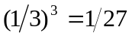and so the moment of inertia would decrease by a factor of 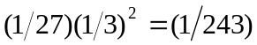, and for the same spring constant, the frequency and angular frequency would increase by a factor of 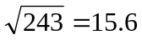. b) The torsion constant would need to be decreased by a factor of 243, or changed by a factor of 0.00412 (approximately).

